International Association of Machinists and Aerospace Workers
9000 Machinists Place
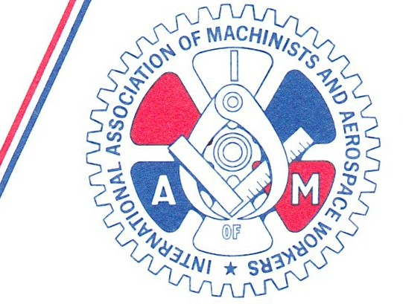
Upper Marlboro, Maryl and 20772-2687

Area Code 301
967-4500

November 9, 2018

Subj: 2019 Women's Conference April 3 - 6, 2019
Bally's Las Vegas

To all 1AM Directing Business Representatives, Business Representatives , District Lodge Presidents, District Lodge Secretary-Treasurers, Local Lodge Presidents and Local Lodge Recording Secretaries in the United States and Canada:

Dear Brothers and Sisters:

This will serve as the official call to the IAMAW's 2019 Women's Conference.
Registration will be held on Wednesday, April 3, 2019 from 2:00 pm-5:00 pm and continues on Thursday, April 4 from 7:30 am - 9:00 am. The conference will convene at 9:00 am Thursday, April 4 and will conclude with an Appreciation/Awards Dinner at 5:00 pm Saturday April 6.

The conference venue is Bally's Las Vegas, 3655 Las Vegas Blvd . South, Las Vegas, Nevada 89109. We have secured a limited room block with a discounted rate of $89.00 (April 2
- 4) and $109.00 (April 5 - 6) plus applicable truces and fees. In order to guarantee your reservation at this rate, please call the Bally's Reservation Center at 702-967-4111 or 800-722- 5597 and request the group rate for the IAMAW Women's Conference or use the group code SBIAM9. Please be aware that there is an additional processing fee for telephone reservations. To avoid the processing fee an online reservation may be made through the hotel web link at:

https://book.passkey .com/go/SMIAM9
The cutoff date for the listed rates is Sunday, March 3, 2019. After that date, we cannot guarantee the special room rate or guarantee the availability of a room.
A discounted registration fee of $100 is available to participants returning the enclosed registration form and payment prior to March 3, 2019. After March 3, the registration fee will increase to $125. Please send completed registration forms to the 1AM Women ' s Department, 9000 Machinists Place, Room 116, Upper Marlboro, MD 20772, Attention: R. Rogers.
Women play a key role in the labor movement. Their involvement is important to economic growth, political stability and social transformation. The conference theme, "Women Rising: Unite the Fight" highlights the importance of the role our Sisters play in today's Labor

Movement and focuses on providing our Sisters with the tools and encouragement to become strong leaders. I encourage our lodges to consider sending delegates to this important event.
Questions should be directed to the Women's Department at 301-967-4747.

RM/rsr

Enclosure

cc: via email: Executive Council GLRs
SRs GLAs
Railroad and Airline GCs Communication and Education Reps

In solidarity,

Robert Martinez, Jr.
International President

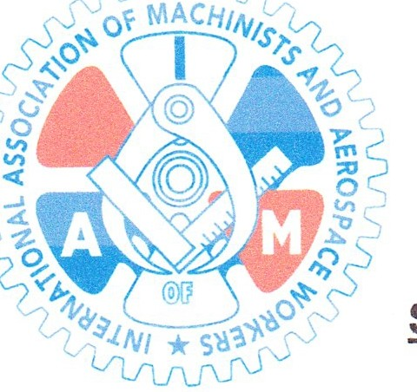
International Association of Machinists & Aerospace Workers Women's Conference
April 3 - 6, 2019

PLEASE RETURN THIS FORM WITH YOUR REGISTRATION FEE

SEND TO: IAMAW Attn: 1AM Women's Department 9000 Machinists Place, Room 116
Upper Marlboro, MD 20772 Phone: (301) 967-4747

CHECKS OR MONEY ORDERS MADE PAYABLE TO THE IAMAW PLEASE DO NOT SEND CASH

1AM Member's Name ------------Member#------
District Lodge Local Lodge Territory _
Address--------------------------

Province/ Postal Code/
City: State: Zip Code _
Phone#(_) Cell Phone (_) _
E-Mail Address: -----------------------

EARLY CONFERENCE REGISTRATION FEE
(REGISTER BY MARCH 3, 2019)
$100.00 per person
AFTER MARCH 3, 2019 REGISTRATION FEE
$125.00 per person

Do you have any special needs while you are attending this conference?

IN CASE OF EMERGENCY, CONTACT:

Name- - - - - - - - - - - - -
Phone Number- - - - - - - - -

