International Association of Machinists and Aerospace Workers
9000 Machinists Place
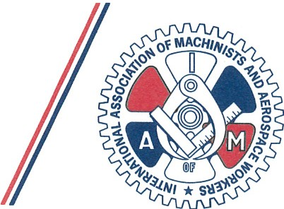
Upper Marlboro, Ma1yalnd 20772-2687

Area Code 30 1
967-4500

OFFICE OF THEINTERNATIONAL PRESIDENT

November 2, 2018

Subj: 2019 Communications Conference Las Vegas, Nevada

To All District Lodge Presidents and Secretary-Treasurers, Local Lodge Presidents and Recording Secretaries, Directing Business Representatives, Business Representatives, TCU Carmen Division Officers, National Representatives, Assistant National Representatives and Local Lodge Officers

Dear Brothers and Sisters :

This is the official call for the 2019 IAM Communications Conference scheduled for Tuesday, June 4 through Thursday, June 6, 2019, at the Planet Hollywood Resort and Casino , 3667 Las Vegas Blvd., Las Vegas, NV 89109.
International President Robert Martinez Jr. will chair this conference and direct the busy agenda. Plan to arrive on Monday, June 3. Conference registration begins at 2 p.m. to 5 p.m. and continues on Tuesday, June 4 from 7:30 a.m. to 9 a.m. The conference will conclude with our awards dinner on the evening of Thursday, June 6. Please plan your departure for Friday, June 7.
For this important conference, we have arranged for a special room rate of $75, plus taxes and a $37 resort fee per night for single or double occupancy. When calling for a reservation, please be aware that there is an additional processing fee. The telephone number for reservations is 702-785-5555 or 866-919-7472. Please request the group rate for IAMAW Communications Conference or group code SMIAM9. An online reservation may be made with no processing fees through our hotel web link at

https://book.passkey .com/go/SMIAM9.
The cutoff date for this rate is Friday, May 3, 2019. After that date, we cannot guarantee the special room rate or guarantee the availability of a room.
There is a $100 conference registration fee. If possible, the registration fee should be paid when you return the enclosed registration form; no cash will beaccepted at registration.
Please send completed registration forms to the 1AM Communications Department by mail to 9000 Machinists Place, Upper Marlboro, MD 20772 or by email to tcrutchfield@iamaw.org.

The Communications Conference is a great learning experience. This is a unique opportunity to master the skills needed to be effective communicators.
I plan to actively participate in the workings of this year's conference. I sincerely urge all of you to plan your time and budgets to join us for what I know will be a rewarding experience for you. If there are any questions concerning this conference, please direct them to the Communications Department at (301) 967-4520 .

In solidarity,

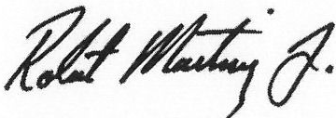
Robert Martinez Jr. International President

RM/tc Enclosures
cc sent via email:
Executive Council GLRs
SRs GLAs
Railroad and Airline GCs Communication and Education Reps

International Association of Machinists & Aerospace Workers Communications Conference
June4-6,2019

The following delegate will attend the 1AM Communications Conference.
One form per delegate, please.

Name
Title
Street
City |  | State/Province ZIP
Phone  GVP |  | Email
DL# | LL#

□ $100 Registration Fee Per Delegate Enclosed (includes banquet ) This check covers the registration fee for:

- $35 Guest Banquet Fee Enclosed
- Will Pay at Registration

NO CREDIT CARDS
NO CASH Mail completed form to:
IAMAW

Communications Conference Registration 9000 Machinists Place, Room 303-D Upper Marlboro, Maryland 20772-2687
Phone: 301967-4520 Fax: 301 967-4586

Lodge Officer's signature, Title
(Mandatory)

Lodge Seal
(Mandatory)

